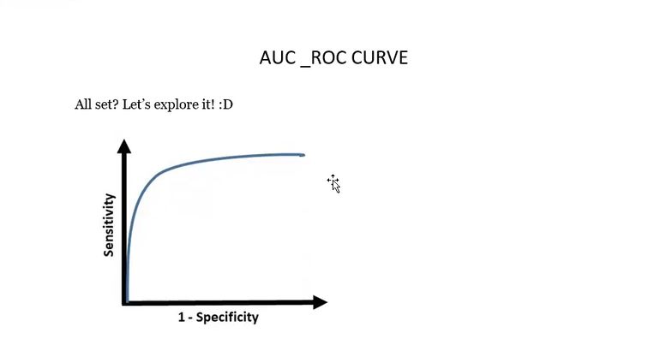

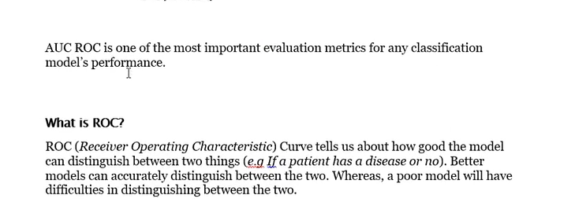

Let's assume we have a model which predicts whether the patient has a particular disease or no. The model predicts probabilities for each patient (in python we use the" predict proba" function). Using these probabilities, we plot the distribution as shown below:

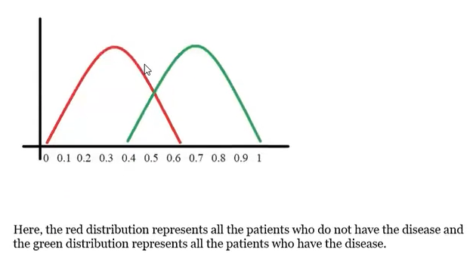

Now we got to pick a value where we need to set the cut off i.e. a threshold value, above which we will predict everyone as positive (they have the disease) and below which will predict as negative (they do not have the disease). We will set the threshold at "0.5" as shown below:

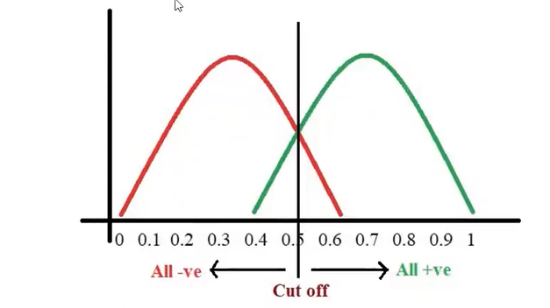

All the positive values above the threshold will be "True Positives" and the negative values above the threshold will be "False Positives" as they are predicted incorrectly as positives.

All the negative values below the threshold will be "True Negatives" and the positive values below the threshold will be "False Negative" as they are predicted incorrectly as negatives.

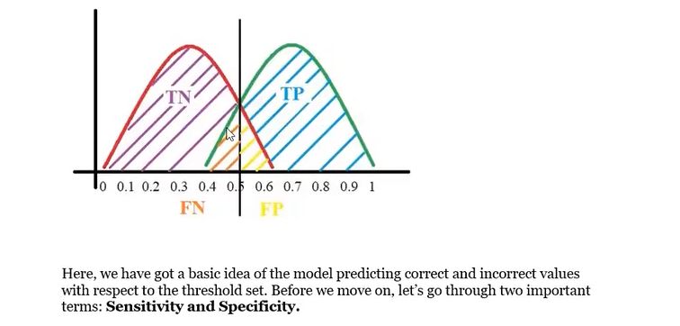

-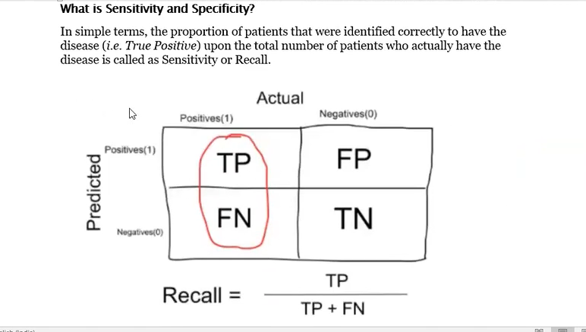

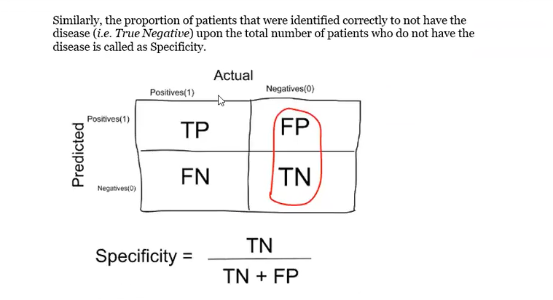

**Trade-off between Sensitivity and Specificity**

When we decrease the threshold, we get more positive values thus increasing the sensitivity. Meanwhile, this will decrease the specificity.

Similarly, when we increase the threshold, we get more negative values thus increasing the specificity and decreasing sensitivity.

As Sensitivity Specificity 1

As Specificity Sensitivity 1

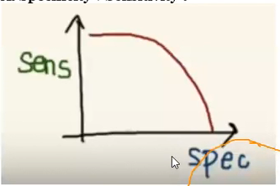

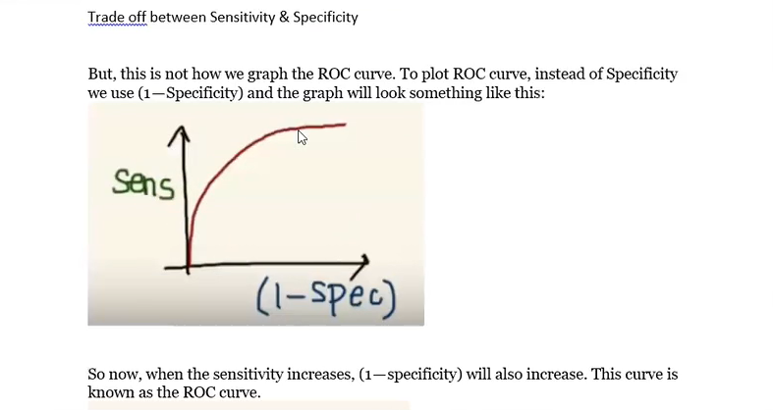

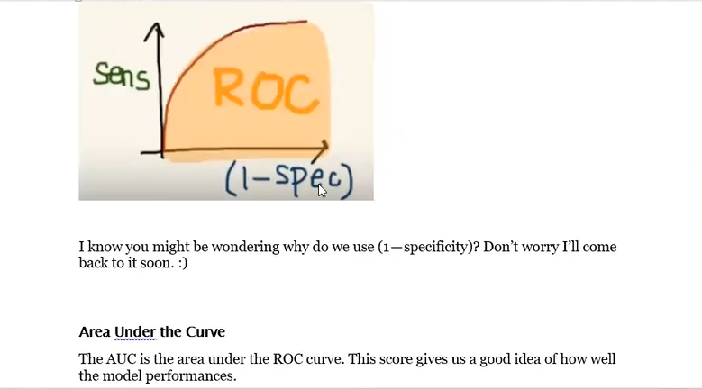

Lets take few examples:

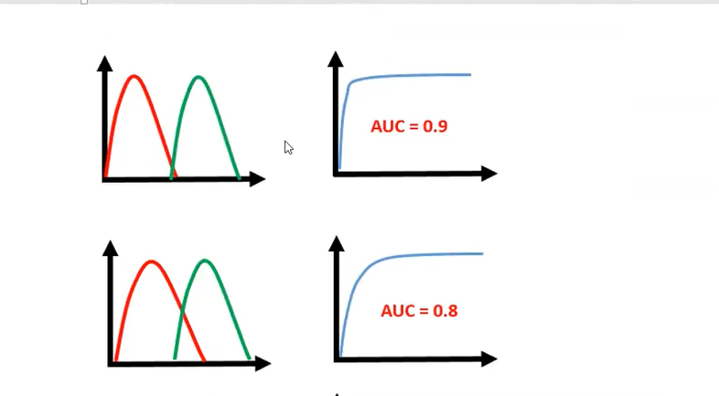

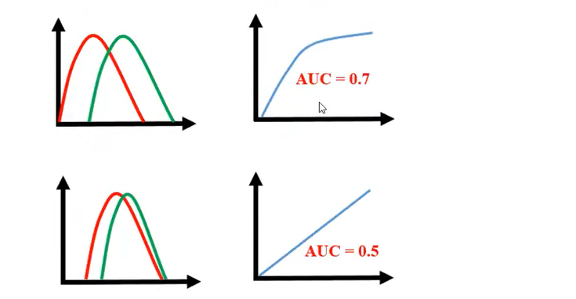

As we see, the first model does quite a good job of distinguishing the positive and the negative values. Therefore, there the AUC score is 0.9 as the area under the ROC curve is large.

Whereas, if we see the last model, predictions are completely overlapping each other and we get the AUC score of 0.5. This means that the model is performing poorly and it is predictions are almost random.

